1. **Project Profile**

|  |  |
| --- | --- |
| PROJECT NAME | Agriculture Marketing |
| PROJECT TYPE | Desktop application |
| STREAM | TY BCA (SEM-5) |
| FRONT END | PHP |
| BACK END | MYSQL |
| Internal guide | Mr. V. K. Bhaliya |
| Submitted to | Saurashtra University - Rajkot |
| Submitted by | Jatin C. Ramani  Nilesh K. Ghoghari |

**1.1 Introduction**

* The agriculture industry plays a critical role in ensuring security and economic challenges in effectively marketing their product resulting in lower profitability and limited market access.
* To address these issues and promote sustainable agriculture practices, we have undertaken in innovative agriculture marketing project.
* **Objective**
* The primary objective of our project is to revolutionize the marketing landscape for agriculture products by employing modern techniques and technology. Our aim is to empower farmers enhance their market visibility, impower profitability and facilitate better connections between producers and consumer, by leveraging advance, marketing. Strategic, we seek to bridge the gap between the agriculture sector and the larger consumer market Fostering a sustainable and resilient system.
* **Digital platform**
* We have developed an intuitive end user friendly digital platform their serves as a centralised hub for farmers Buyer said authorised stakeholders this platform allows farmers to showcase their product excess market information and connect directly with potential buyers.
* It also provides buyers visa convenience and transparent way to discover and procure Agriculture products directly from farmers
* **Why did we need agriculture marketing system**

1. **Market access:** Farmers need at efficient agricultural marketing system to connect with potential bias in reach wider market without a proper marketing system farmers managed global to sell safe products over have limited access to buyers resulting in lower profitability and limited opportunities for growth.
2. **Price Discovery:** a well-functioning Agriculture marketing system facilitates bright discovery with refers to the process of determining fare prices for agriculture products baseball supply and demand dynamic by providing farmers with express to market information and transparent pricing mechanism they can make informed This is an above fair pricing strategy and negotiate before Price for their product.
3. **Market information and intelligence:** An agricultural marketing system provide farmers with valuable market information and intelligence. These include date on consumer pre preference, Market trends imaging demands and competitive analysis excess to such information helps farmers make informed design about crops selection production planning and marketing strategies improving their chances of success in the market.

* **Problem definition**
* **Price volatility:** Agriculture market has prone to price function due to factor such as weather conditions global market trends and supply demand imbalances Farmers pays the rise to opera volatility with a negatively Inspector income and financial stability the lake of mechanism for price discovery and risk Management exacerbate this issue.
* **Limited market linkages**
* Farmers pay challenges in establishing Dial up connexion with buyer including retailer progress and exporters. the absence of platform or intermediaries that Facilities efficient and transaction interaction between farmers Ebuyer’s make a difficult for farmers to market their products effectively.

**1.2 Scope of project**

1. **Product listing:**

* The website can provide a platform for farmers to showcase their agriculture product it should allow farmers to create profile and list their product with detailed description, pricing information and product image is too featuring help buyers to discover and evaluate the available product

1. **Market information**

* The website can provide relevant market information to farmers and buyers. this can include price trends, market analysis, demand forecasts, and info on consumer preference by offering valuable market insights, The website helps farmers make inf decision about their production and marketing strategy

1. **Hardware & Software Requirements Tools & Technology**

**2.1 Hardware Requirement**

1. **Processor:** On modern processes that get Intel Core I5 AMD equivalent is recommended
2. **Ram:** at least 4GB of RAM, although 8GB RAM For more is preferable for smother performance
3. **Storage:** Sufficient disk space to store your project files database and any dependencies or minimum 10GB is recommended
4. **Display:** A monitor with a resolution of 1280 * 800 or higher for comfortable development
   1. **Software requirement**

**1. Operating system:** PHP is compatible with various operating systems, including windows, mac OS, and Linux. Choose an OS that you are comfortable with or that aligns with your project requirement.

1. **Web server:** You need a web server to host your PHP project and most popular option include Apache Web server.
2. **PHP:** install the PHP programming language on your system.
3. **Database**: If your project requires database functionality install and configure a suitable database server common choice includes MYSQL.
4. **Text editor or IDE:** Choice text editor or IDE to write your PHP code popular option includes visual studio code**.**
5. **Browser:** You need a web browser to test and pre your PHP project use the latest Version of browser like Google Chrome Mozilla Firefox or Safari for compatibility and optimal performance.

**2.3 Tools and technology**

|  |  |
| --- | --- |
| **software** | **Remark** |
| MySQL | Used as the back for the system. it holds the entire database |
| PHP | It is the technology used as the scripting language |
| Windows XAMPP | Use to run Apache web server on server said |
| MS Word | Used to documentation tools |
| Internet | Used as the Communication tools |
| VS code | Used as code editor |

* **PHP**
* Hypertext processor is a server-side scripting language designed in four web development but also use the general-purpose programming language it was originally restated by resume ledorf is 1945 the PHP reference in implementation Is now produced by the PHP group PHP originals stoop for personal home page but is now for personal home page, but it now stands for the recursive initialism.
* PHP CODE main embedded into HTML code or it can be used in combination with various web templates systems web content management systems and web frameworks PHP code is usually processed by a PHP interpreter implemented as a module in the web server OR as COMMON gateway interface CGI executable table. The webservers’ combinations the results of the interpreted end executed PHP code which may be any type of data including images with generated web page PHP code may be also executed with a command line interface and can be used to implement standalone graphical application.
* The standard PHP interpreter powered by the Zend engine is free software released under the PHP licence PHP has been wired ported and can be developed on most web servers on almost every operating system and platform free work charge
* **The PHP language**: evolved without a written Formal specification or standard until 2014, with the original implementation acting as the de facto standard which other implementations aimed to follow. since 2014 work has gone on to create a formal PHP specification.
* es that the new language will drive interlay IDEA sales.
* Jet brain hop PHP development began in 1994 when Rasmus ledorf wrote several common gateway interface programs in c, which he used to maintain his personal homepage. he extended them to work with web forms and to communication with databases, and called this implementation “personal home page/forms interpreter “or PHP/FI.
* PHP/FI could be used to build simple, dynamic web application. to accelerate bug reporting and improve the code, lerdorf initially announced the release of PHP/FI as “personal home page tools (PHP TOOLS) version 1.0” on the UseNet discussion group comp. info systems. www authoring .CGI on June 8,1995. This release already had the basic functionality that PHP has today. this includes Perl-like variables, form handling, and the ability to embed HTML. the syntax resembled that of Perl, but was simpler more limited and less consistent.
* Early PHP was not intended to be a new programming language, and grew organically, with ledorf noting in represent. I don’t know how to stopit, there was never any intent to write a programming language […] I have absolutely no idea how write a programming language. I just kept adding the next logical step on the way a development team began to form and, after months of work and data testing officially released PHP/FI 2 in November 1997.
* The fact that PHP was not originally designed, but instead was developed organically has led to inconsistent ordering of their parameters, in some cases, the function names were chosen to match the lower-level libraries which PHP was “wrapping”, while in some very early versions of PHP the length of the function Names was used internally as a hash function, so names were chosen to improve the distribution of hash values.
* **MySQL**
* MySQL is an open – source relational database management system (RDBMS). Its name is a combination of “My” the name of cofounder Michael widen us’ daughter, and “SQL”, the abbreviation for structure query language. the MySQL development project has made its source code available under the term of the GNU general public license, as well as under a variety of proprietary agreements. MySQL was owned and sponsored by a single for – profit firm, the Swedish company MySQL ab, Now owned by oracle corporation for proprietary use, several paid editions are available, and offer additional functionality.
* MySQL is a central component of the LAMP open – source web application software stack (and other “AMP” STACKS) LAMP is an acronym for “Linux”, Apache, MySQL database include: MODX, JOOMLA, WORDPRESS, SIMPLE machines forum, PHPBB, MYBB, and DRUPAL. MySQL IS also used in many high – profile, large-scale website, including google (though not for search), Facebook, twitter, Flickr, and YouTube.
* **XAMPP**
* XAMPP is a free and open-source crass package developed by Apache friends, consisting mainly of the Apache HTTP server, MariaDB database, and interpreters for script written in the PHP and Perl programming language. XAMPP stand for cross-platform (X), APACHE (A), MARIADB (M), PHP (P), AND PERL (P). it is a simple, lightweight Apache distribution that makes it extremely easy for developers to create a local web server for testing and deployment purpose.
* Everything needed to set up a web server – server application (Apache), database (MariaDB), AND scripting language (PHP) in include in an extractable file. XAMPP is also cross-platform, which means it work equally well on Linux, mac and windows. Since most actual webserver deployments use the same components as XAMPP, it makes transitioning from a local test server to a live server extremely easy as well.
* The term XAMPP is an apparent acronym. however, there is no official acronym expansion specified on the Apache friend’s website. their homepage header reads “XAMPP Apache + MariaDB + PHP + PERL” indicating that this abbreviation is a recursive acronym.
* **Java script**
* JavaScript , often abbreviated as JS, is a high – level, interpreted programming language. it is a language which is also characterized as dynamic, weakly typed prototype – based and multi – paradigm alongside HTML and CSS, java script is one of the three core technologies of world wide web content engineering
* It is used to make dynamic webpages interactive and provide online programs. Including video games. the majority of website. employ it, and all modern web browsers support it, without the need for plug – ins by means of a built – in java script engine. each of many java script engines represent a different implementation of JavaScript all based of the ECMA script specification on, with some engines not supporting the spec fully, and with many engines supporting additional features beyond ECMA.
* As s multi-paradigm language JavaScript supports event -driven function and imperative concluding object – oriented and prototype – based programming style it has an API for working with text arrays dates regular, expressions and basic manipulation of the Dom but the language itself does not include any I/O such as networking stage , or graphics facilities relying for these the host environment in which it is embedded.
* **Visual studio code**
* Visual studio code editor with a python application programming interface (API) IT natively supports many programming language and markup language, and functions came be added by users with plugging typically community built and maintained under free – software licenses.

**3. Information Gathering**

1. **what kind of visitors are you expecting to your agriculture marketing website**

* **farmers and growers:** this are the primary audience for an agriculture marketing website they would be interested in information about new farming technology, equipment crop management practices and market trend.

1. **Name two or more of your competitors and describe how you differ them?**

* When you want to agriculture marketing there are hundreds of options for you to choose from but my competitors are AGMARKNET and GUJARAT STATE AGRICULTURE MARKETING BORD.

1. AGMARKNET **:** Research and information network (MIRN) A sub scheme of ISAM was launched in march 2000 to provide electronic connectivity to the wholesale market of the country.

* The objective is to collect analyse and disseminate market information to the farmers, traders, policy market and other stakeholders
* **Objective:**
* To facilitate collection and dissemination of information related to better price dissemination of market information and data for its efficient and timely utilisation realization and market access by the farmers.

1. Market related information
2. Price related information
3. Infrastructure related information
4. Market requirement related information
5. **GUJARAT STATE AGRICULTURE MARKETING BOARD:**

* To co-ordinate the working of the market committee for developing the market yard /sub-yard.
* To undertake the State level planning of the development of agricultural produce markets subject to directions of the State Government.
* To administer the Development Fund.
* To supervise and guide the market committees on request in respect of the preparation of plans as also the construction of infrastructural facilities in the market yards.
* To assist, undertake collection, compilation and publication of market intelligence and statistics as also to promote market survey and conducting research in the field of agricultural marketing.
* To promote and undertake grading and standardization of agricultural produce.
* To arrange and organize seminars, workshops, camps, conferences and exhibitions in the state on agricultural marketing.
* To grant subsidy and loans to needy market committees for the purpose of this Act.
* To provide technical and legal assistance to the market committee on request.
* To promote and assist marketing of agricultural produce in areas where there is no regulation of market under this Act.

1. **What feature should your agriculture marketing website contain?**
   * **User side:**

* User registration & login
* User Add post
* User Manage post
* User Add product
* User Manage seller
* User Add district
* Show price page and search district
* Show news, about, contact, pages
* User logout

* + **Admin side:**
* Admin login
* Admin add post
* Admin manage post
* Add product
* Manage sellers
* Add district
* Add user
* Manage users
* Add category
* Manage categories

1. **Do you ship order of item?**

* No, we will not be shipping any items user can just know only the price of items and get news about it.

1. **Do You Have any colour preferences or look and feel for the agriculture marketing websites?**

* I want a very simple look in my website so that the customer can easily see his/her products and get the price details and get the news does not have the hassle of ordering the product.
* I want grey colour in my site and simple background with login page.

1. **What is your target audience?**

* when creating an agriculture marketing website, its crucial to define a clear target audience to tailor your content design, and features to their needs and preferences. The agriculture industry is divers, so identifying your specific target audience will help you effectively communicate with them and meet their requirements. Here are some potential target audiences for an agriculture marketing website.

1. **farmers and growers**
2. **agriculture suppliers**
3. **agribusiness professionals**
4. **investors and stakeholders**
5. **user roles and features?**

* For an agriculture marketing and news website, you many have different user roles and corresponding features to create to the needs of various stockholders in the agriculture industry here are some potential user roles and the features associated with each role.

1. **Farmers and growers**

* User profile: allow farmers to create profile and manage their information.
* Marketplace: provide a platform for farmers to list their products for sale and connect with potential buyers.
* News and insights: offer articles, blogs, management, best practices, and market trends.

1. **Purpose your website?**

* the primary purpose of an agriculture marketing website is to disseminate timely and relevant information about the agriculture sector and market yard
* this includes news, update, trend, related to various aspect of agriculture such as crop production investor farming, market prices.

**4. Feasibility Study**

A purpose of feasibility study is to check out the possibility of a computerized solution to the organization’s observed problem before very much money that has been spent on.

A feasibility study is carried out to select the best system that meets performance requirements.

Only by spending the time to evaluate the feasibility do I reduce the

chances for extreme embarrassment at later stage of the system project.

For the complete feasibility study, I need to concentrate on following area:

* **Technical Feasibility**
* **Economic Feasibility**
  1. **Technical Feasibility:**

⦁ Technical feasibility Central on existing computer system and to what extend it can support the proposed system addition.

⦁ For Example, your current system is operating at 70% capacity then other application could overload the system or required additional hardware.

⦁ If the budget is serious constrain then the project judge not feasible.

**Software**

|  |  |
| --- | --- |
| OPERATING SYSTEM | WINDOWS 10 OR ANY OTHER WINDOWS BASED OPERATING SYSTEM WHICH IS EASILY AVAILABLE |
| MYSQL DBMS SERVER | USE FOR STORING DATA DYNAMICALLY |
| WEB BROWSER | FOR RUN THE SYSTEM LIKE GOOGLE CHROME, MOZILA, FIREFOX, BRAVE |
| VS CODE | FOR DEVELOPMENT OF WEBSITE CODING. |

**4.2 Economic Feasibility:**

**Hardware**

|  |  |  |
| --- | --- | --- |
| NO | HARDWARE NAME | WHICH USE IN PROJECT |
| 1 | RAM | 16GB |
| 2 | PROCESSOR | INTEL CORE I5 |
| 3 | KEYBOARD & MOUSE | - |

**Hardware Cost**

|  |  |  |
| --- | --- | --- |
| NO | HARDWARE NAME | PRICE |
| 1 | RAM (4GB) | RS.879 |
| 2 | PROCESSOR (INTEL CORE I3) | RS.2199 |
| 3 | KEYBOARD & MOUSE | RS.700 |
| 4 | TOTAL COST IN HARDWARE | RS.3778 |

**5. Data Dictionary**

The data Dictionary is a set of tables. SQL uses it to maintain information about this own database.

**➢ Data dictionary contains the following informatio**n:

✓ Name of the table of database.

✓ User information such as Privileges.

✓ Name and data type of all columns in database table.

Database Name: **agriculture**

**Categories**

* This table store to categories details

|  |  |  |  |  |
| --- | --- | --- | --- | --- |
| **No** | **Name** | **Type** | **Null** | **Description** |
| 1 | id | Int (11) | No | To store categories id |
| 2 | Title | Varchar (50) | No | To store categories title |
| 3 | description | Text | No | To store categories description |

**District**

* This table store to district details

|  |  |  |  |  |  |
| --- | --- | --- | --- | --- | --- |
| **No** | **Name** | **Type** | **Null** | **key** | **Description** |
| 1 | d_id | Int (11) | No | Primary key | To store district id |
| 2 | d_name | Varchar (255) | No |  | To store district name |
| 3 | Description | Varchar (11) | No |  | To store district description |
| 4 | user_id | Int (11) | No |  | To store user id |

**Post**

* to store post details

|  |  |  |  |  |  |
| --- | --- | --- | --- | --- | --- |
| **No** | **Name** | **Type** | **Null** | **Key** | **Description** |
| 1 | id | Int (11) | No | Primary key | To store post id |
| 2 | Title | Varchar (255) | No |  | To store post title |
| 3 | body | Text | No |  | To store post body |
| 4 | thumbnail | Varchar (255) | No |  | To store post thumbnail |
| 5 | date_time | Timestamp | No |  | To store post date and time |
| 6 | category_id | Int (11) | Yes |  | To store post category id |
| 7 | Author_id | Int (11) | No |  | To store post author id |
| 8 | is_featured | tinyint (1) | no |  | To store post featured |

**Product**

* to store product details

|  |  |  |  |  |  |
| --- | --- | --- | --- | --- | --- |
| **no** | **Name** | **Type** | **Null** | **Key** | **Description** |
| **1** | p_id | Int (11) | No | Primary key | To store product id |
| **2** | d_id | Int (11) | No |  | To store product d id |
| **3** | Name | Varchar (255) | No |  | To store product name |
| **4** | lowest_price | Int (11) | Yes |  | To store product lowest _price |
| **5** | hight_price | Int (11) | Yes |  | To store product hight_price |
| **6** | category_id | Int (11) | Yes |  | To store product category_id |
| **7** | Date_time | timestamp | No |  | To store product date_time |

**User**

* to store user details

|  |  |  |  |  |  |
| --- | --- | --- | --- | --- | --- |
| **No** | **Name** | **Type** | **Null** | **Key** | **Description** |
| **1** | Id | Int (11) | No | Primary key | To store user id |
| **2** | FirstName | Varchar (50) | No |  | To store user first name |
| **3** | LastName | Varchar (50) | No |  | To store user last name |
| **4** | User Name | Varchar (50) | No |  | To store user name |
| **5** | Email | Varchar (50) | No |  | To store user email |
| **6** | Password | Varchar (255) | No |  | To store user password |
| **7** | Avatar | Varchar (255) | No |  | To store user avatar |
| **8** | is_admin | Tinyint (1) | No |  | To store user admin or note |

**6. Normalization**

**Table:** tblusers

|  |  |  |  |  |  |
| --- | --- | --- | --- | --- | --- |
| 4 | Jatin | Ramani | Jatin | [jatinrmn@gmail.com](mailto:jatinrmn@gmail.com)  [jatinrm2@gmail.com](mailto:jatinrm2@gmail.com) | Jatin123  Jatin123 |
| 25 | Nilesh | Ghoghari | Nilesh | [ghogharinilesh7@gmail.com](mailto:ghogharinilesh7@gmail.com)  [ghogharinilesh8@gmail.com](mailto:ghogharinilesh8@gmail.com) | Nilesh123  Nilesh123 |

**Primary key:** id

**6.1 First Normalization (1NF)**

|  |  |  |  |  |  |
| --- | --- | --- | --- | --- | --- |
| **Id** | **Fname** | **Lname** | **Username** | **Emai** | **Password** |
| 4 | Jatin | Ramani | Jatin | [jatinrmn@gmail.com](mailto:jatinrmn@gmail.com) | Jatin123 |
| 4 | Jatin | Ramani | Jatin | [jatinrm2@gmail.com](mailto:jatinrm2@gmail.com) | Jatin123 |
| 25 | Nilesh | Ghoghari | Nilesh | [ghogharinilesh7@gmail.com](mailto:ghogharinilesh7@gmail.com) | Nilesh123 |
| 25 | Nilesh | Ghoghari | Nilesh | [ghogharinilesh8@gmail.com](mailto:ghogharinilesh8@gmail.com) | Nilesh123 |

|  |  |  |
| --- | --- | --- |
| **id** | **Fname** | **Lname** |
| 4 | Jatin | Ramani |
| 4 | Jatin | Ramani |
| 25 | Nilesh | Ghoghari |
| 25 | Nilesh | Ghoghari |

**6.2 Second Normalization (2NF)**

|  |  |  |
| --- | --- | --- |
| **Id** | **Email** | **Password** |
| **4** | [**jatinrmn@gmail.com**](mailto:jatinrmn@gmail.com) | **Jatin123** |
| **25** | [**ghogharinilesh7@gmail.com**](mailto:ghogharinilesh7@gmail.com) | **Nilesh123** |

**System Analysis**

* 1. **System Flowchart**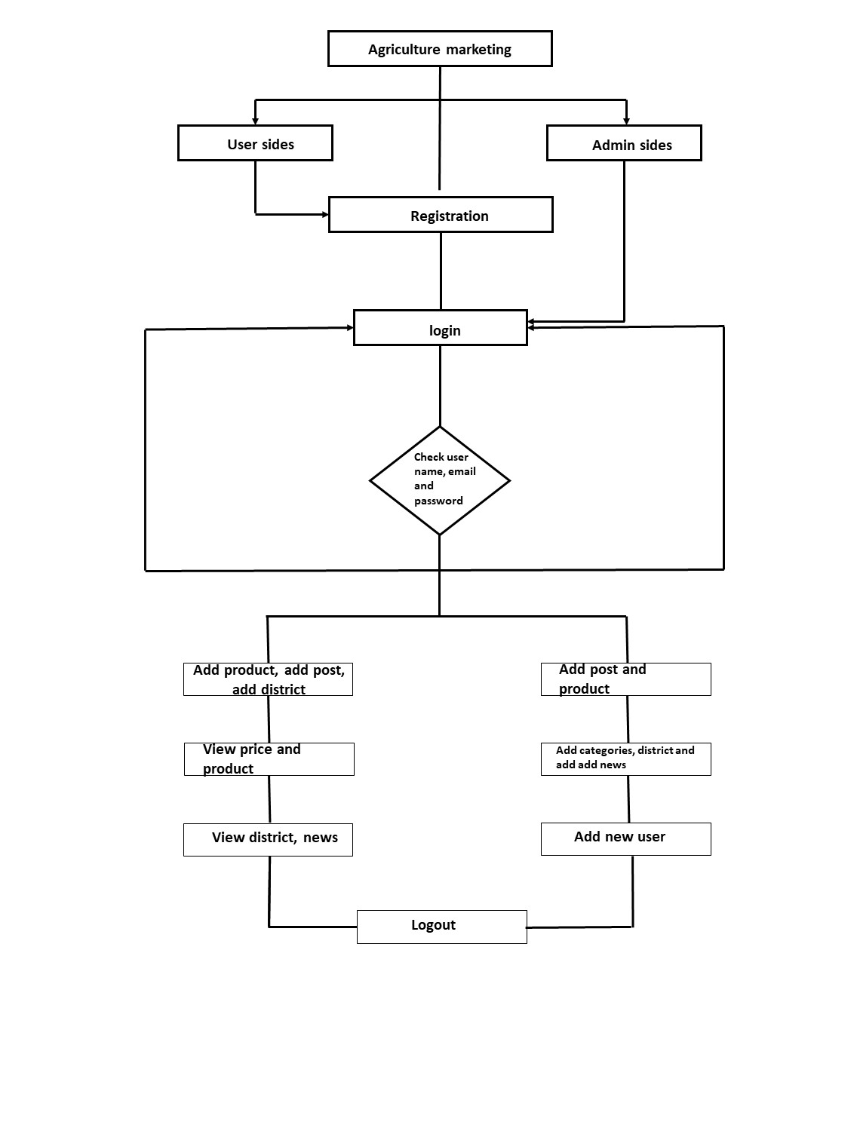

**7.2 ER (Entity Relationship) Diagram**

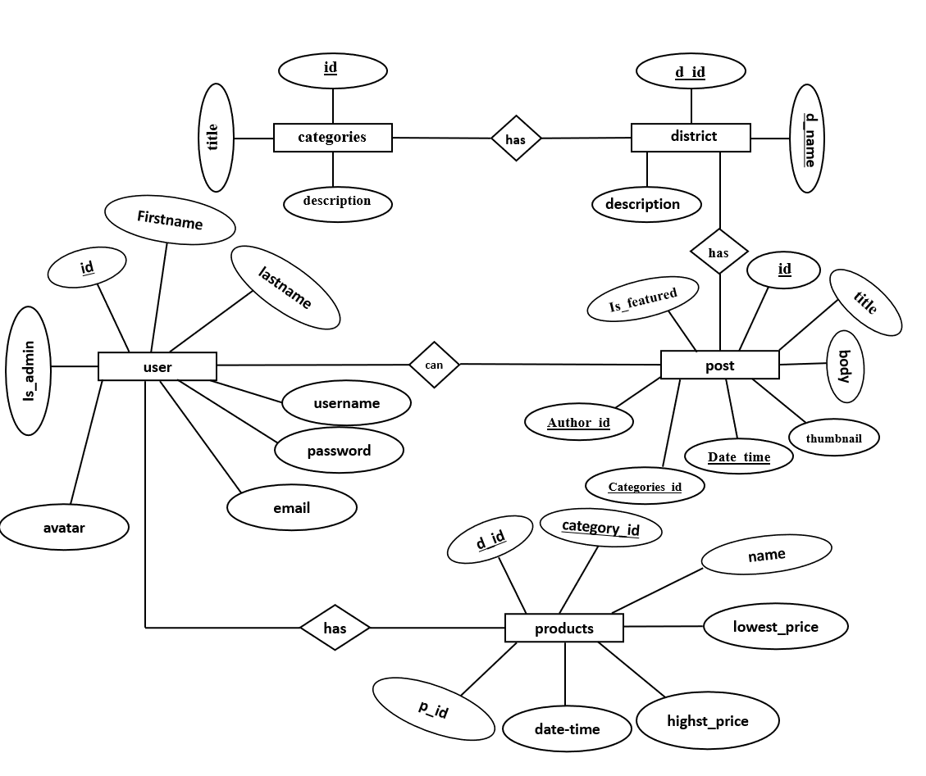

**7.3 Data flow diagram**

* The DFD gives brief idea on how the designed system is working. It also suggests to us the type of users who using this system and the process involved in the system

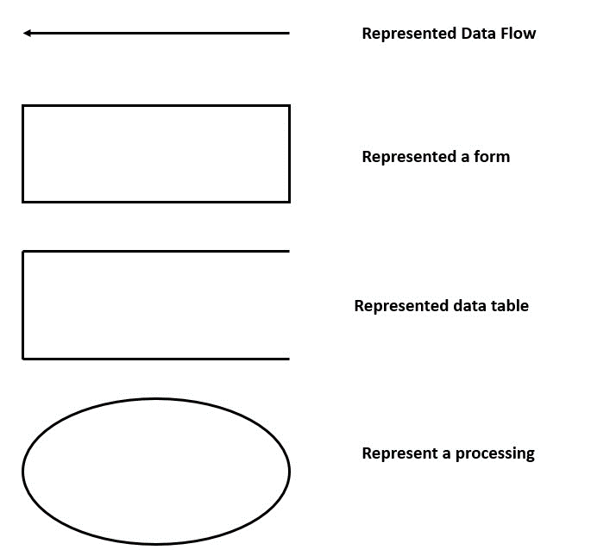

**7.3.1 Context Level Diagram (Level 0)**

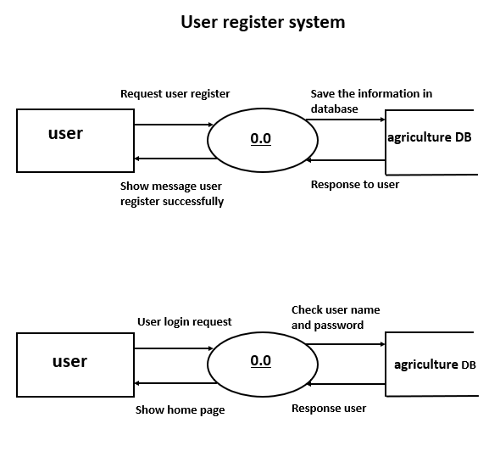

* + 1. **First Level Diagram (Level 1)**

**User side**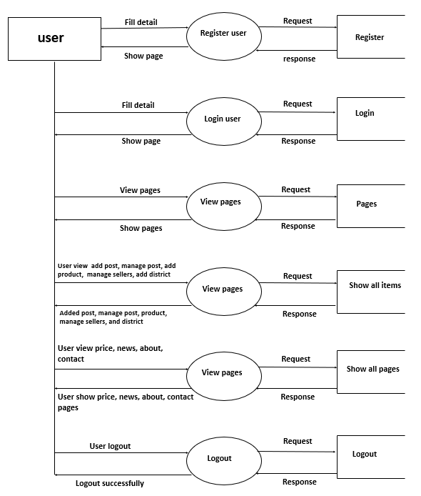

**7.3.3 Second Level Diagram (Level 2)**

**Admin side**

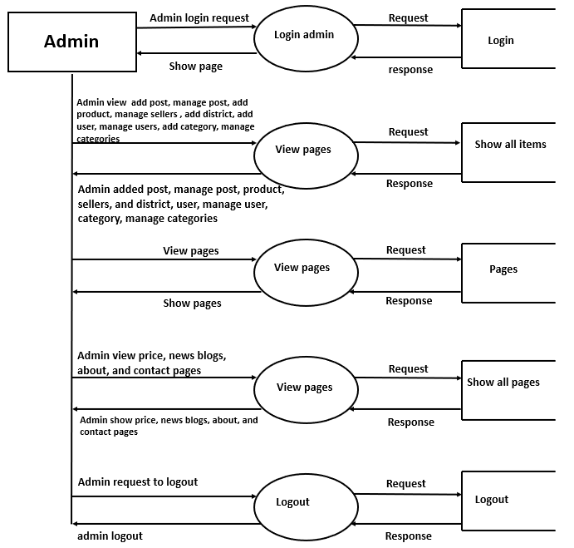

**7.4 Use-case Diagram**

Use case diagrams model behaviour within a system and helps the developers understand of what the user require. The stick man represents what’s called an actor.

Use case diagram can be useful for getting an overall view of the system and clarifying who can do and more importantly what they can’t do.

Use case diagram consists of use cases and actors and shows the interaction between the use case and actors.

* The purpose is to show the interactions between the use case and actor.
* To represent the system requirements from user’s perspective.
* An actor could be the end-user of the system or an external system.

**USECASE DIAGRAM:**

* A Use case is a description of set of sequence of actions. Graphically it is rendered as an ellipse with solid line including only its name.
* Use case diagram is a behavioural diagram that shows a set of use cases and actors and their relationship. It is an association between the use cases and actors.
* An actor represents a real-world object. Primary Actor – Sender, Secondary Actor Receiver.

**User**

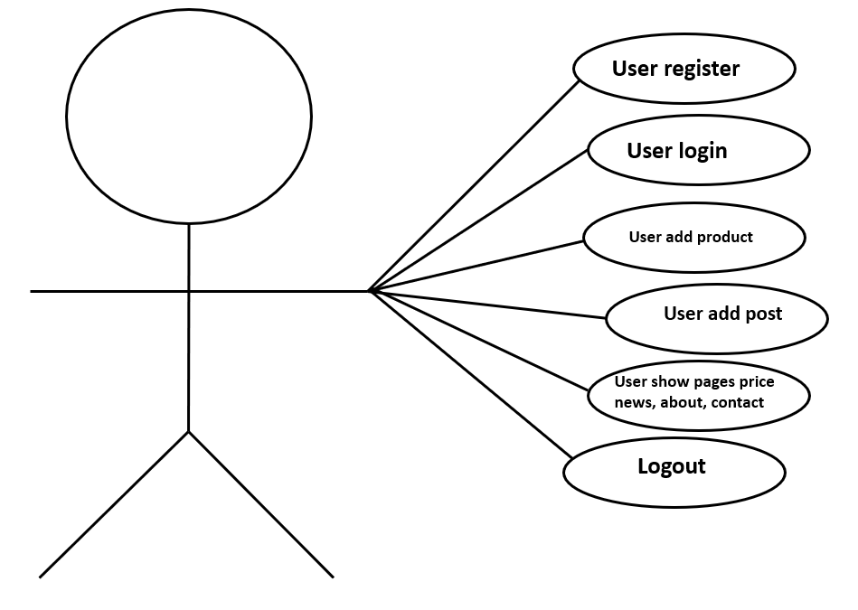

**Admin**

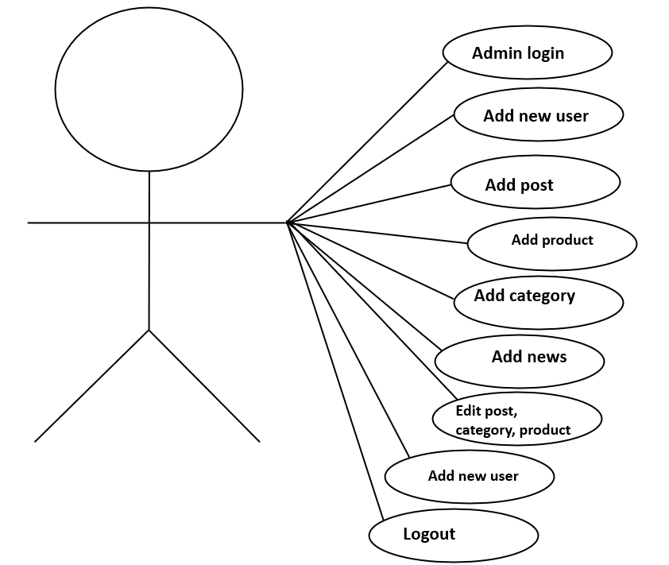

**7.5 Activity Diagram**

**User side** 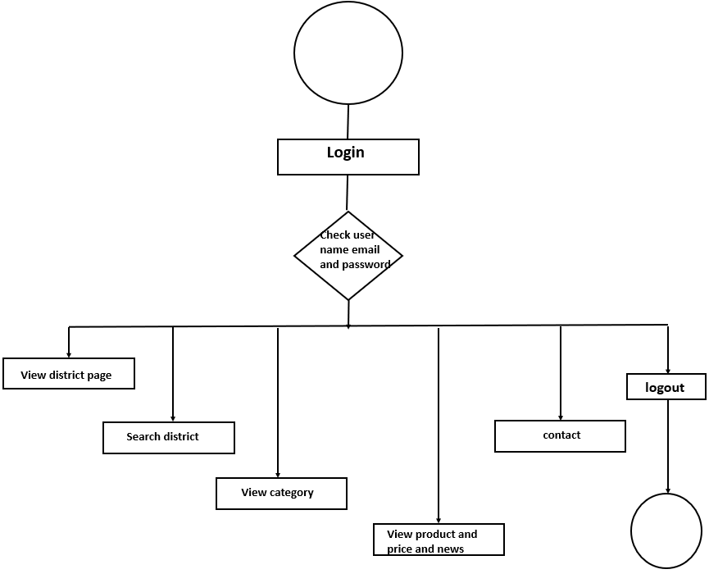

**Admin side**

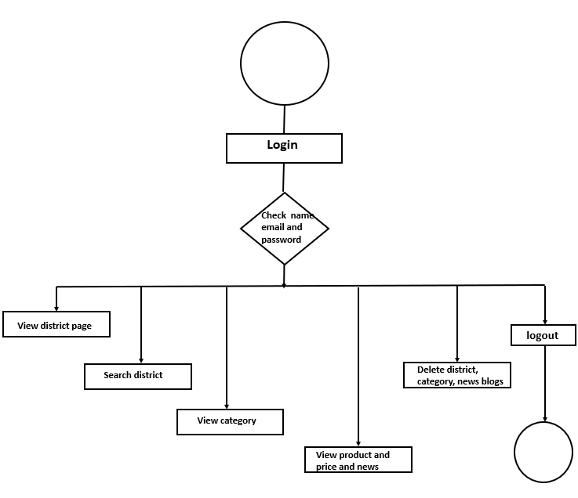

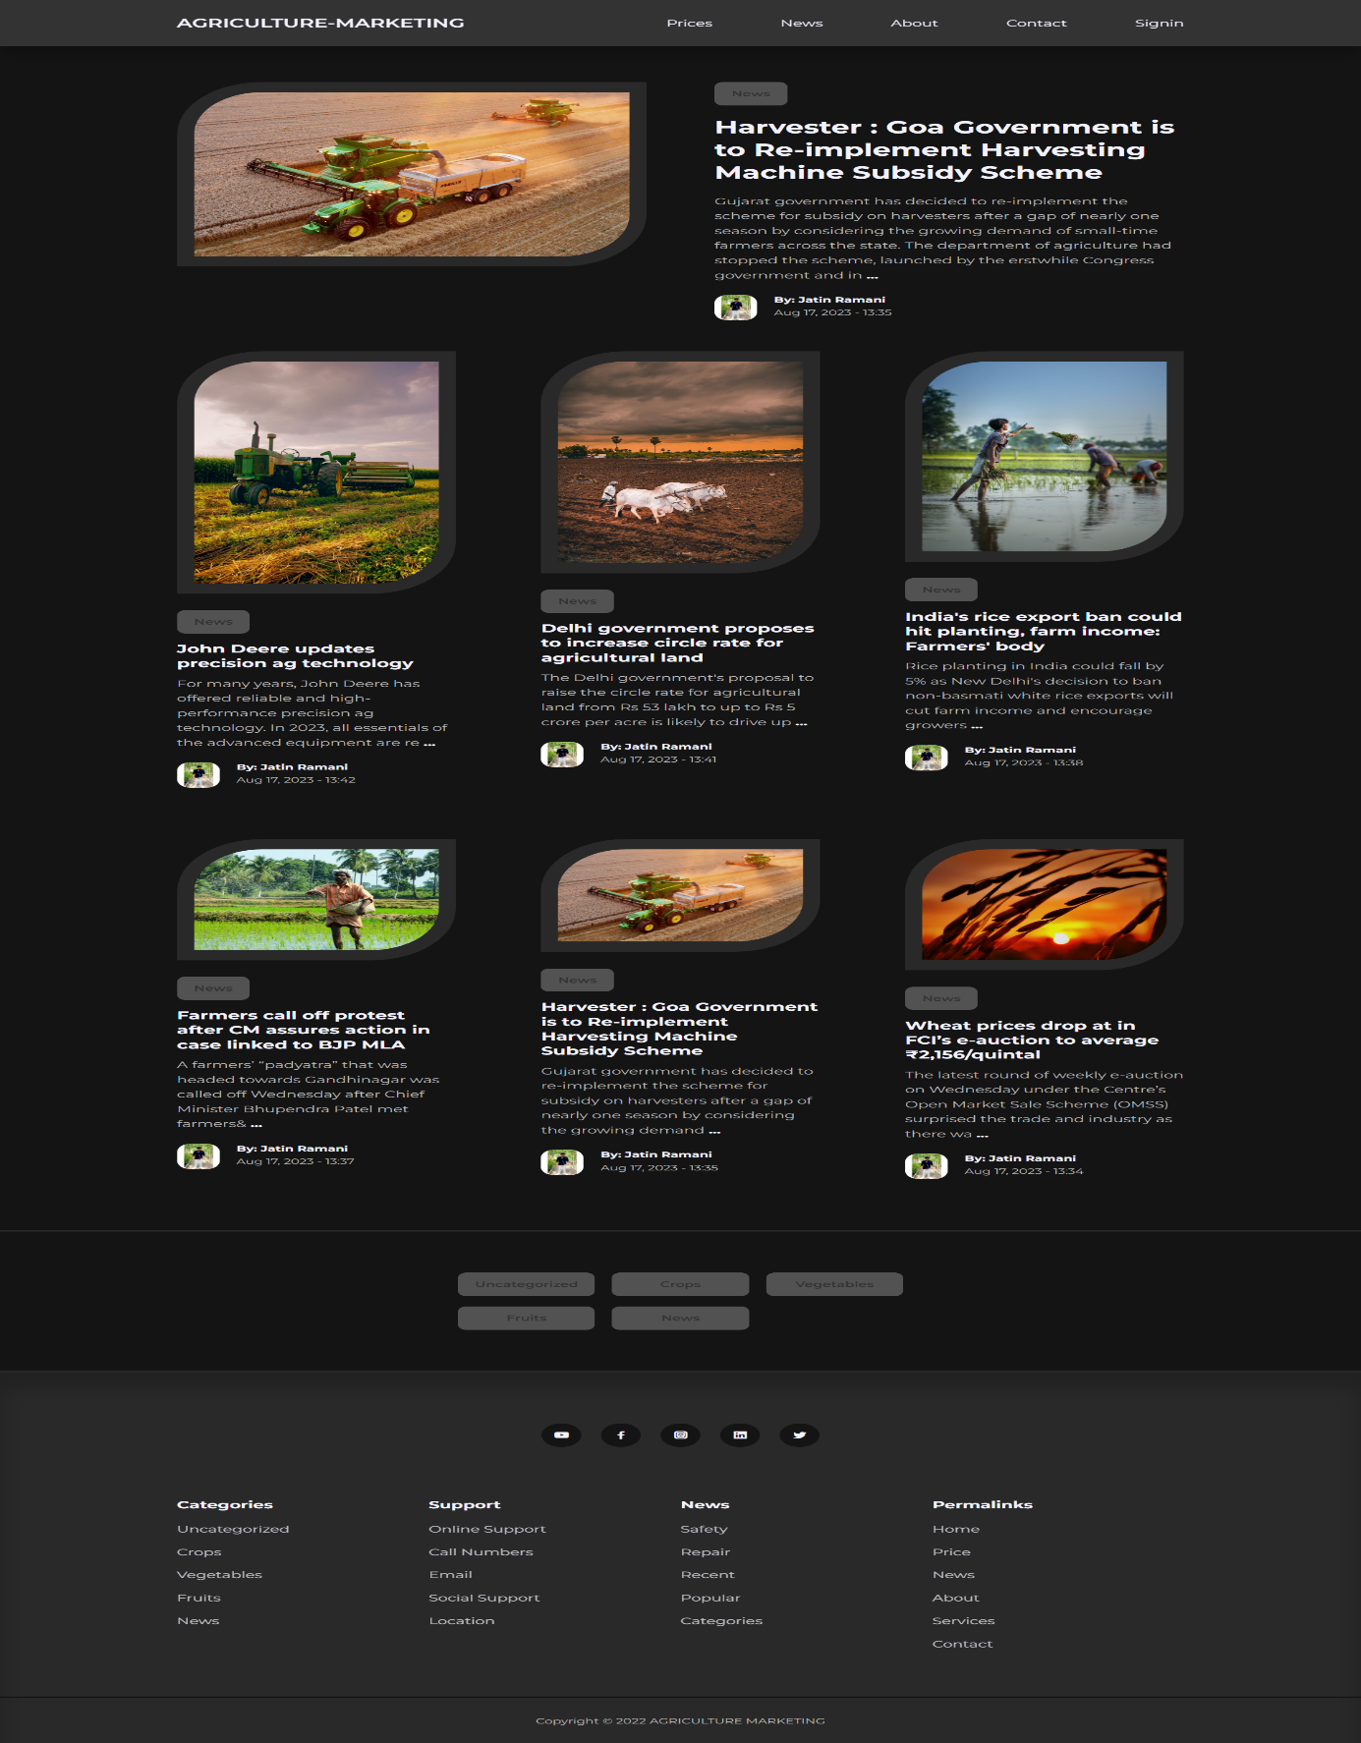**8 System Design**

1. **Home page**

**Description :**

* Above screenshot is Home page where user can view featured Post(News) and up to 9 latest Posts(news).

1. **News Page**

**Description :**

* Above screenshot is 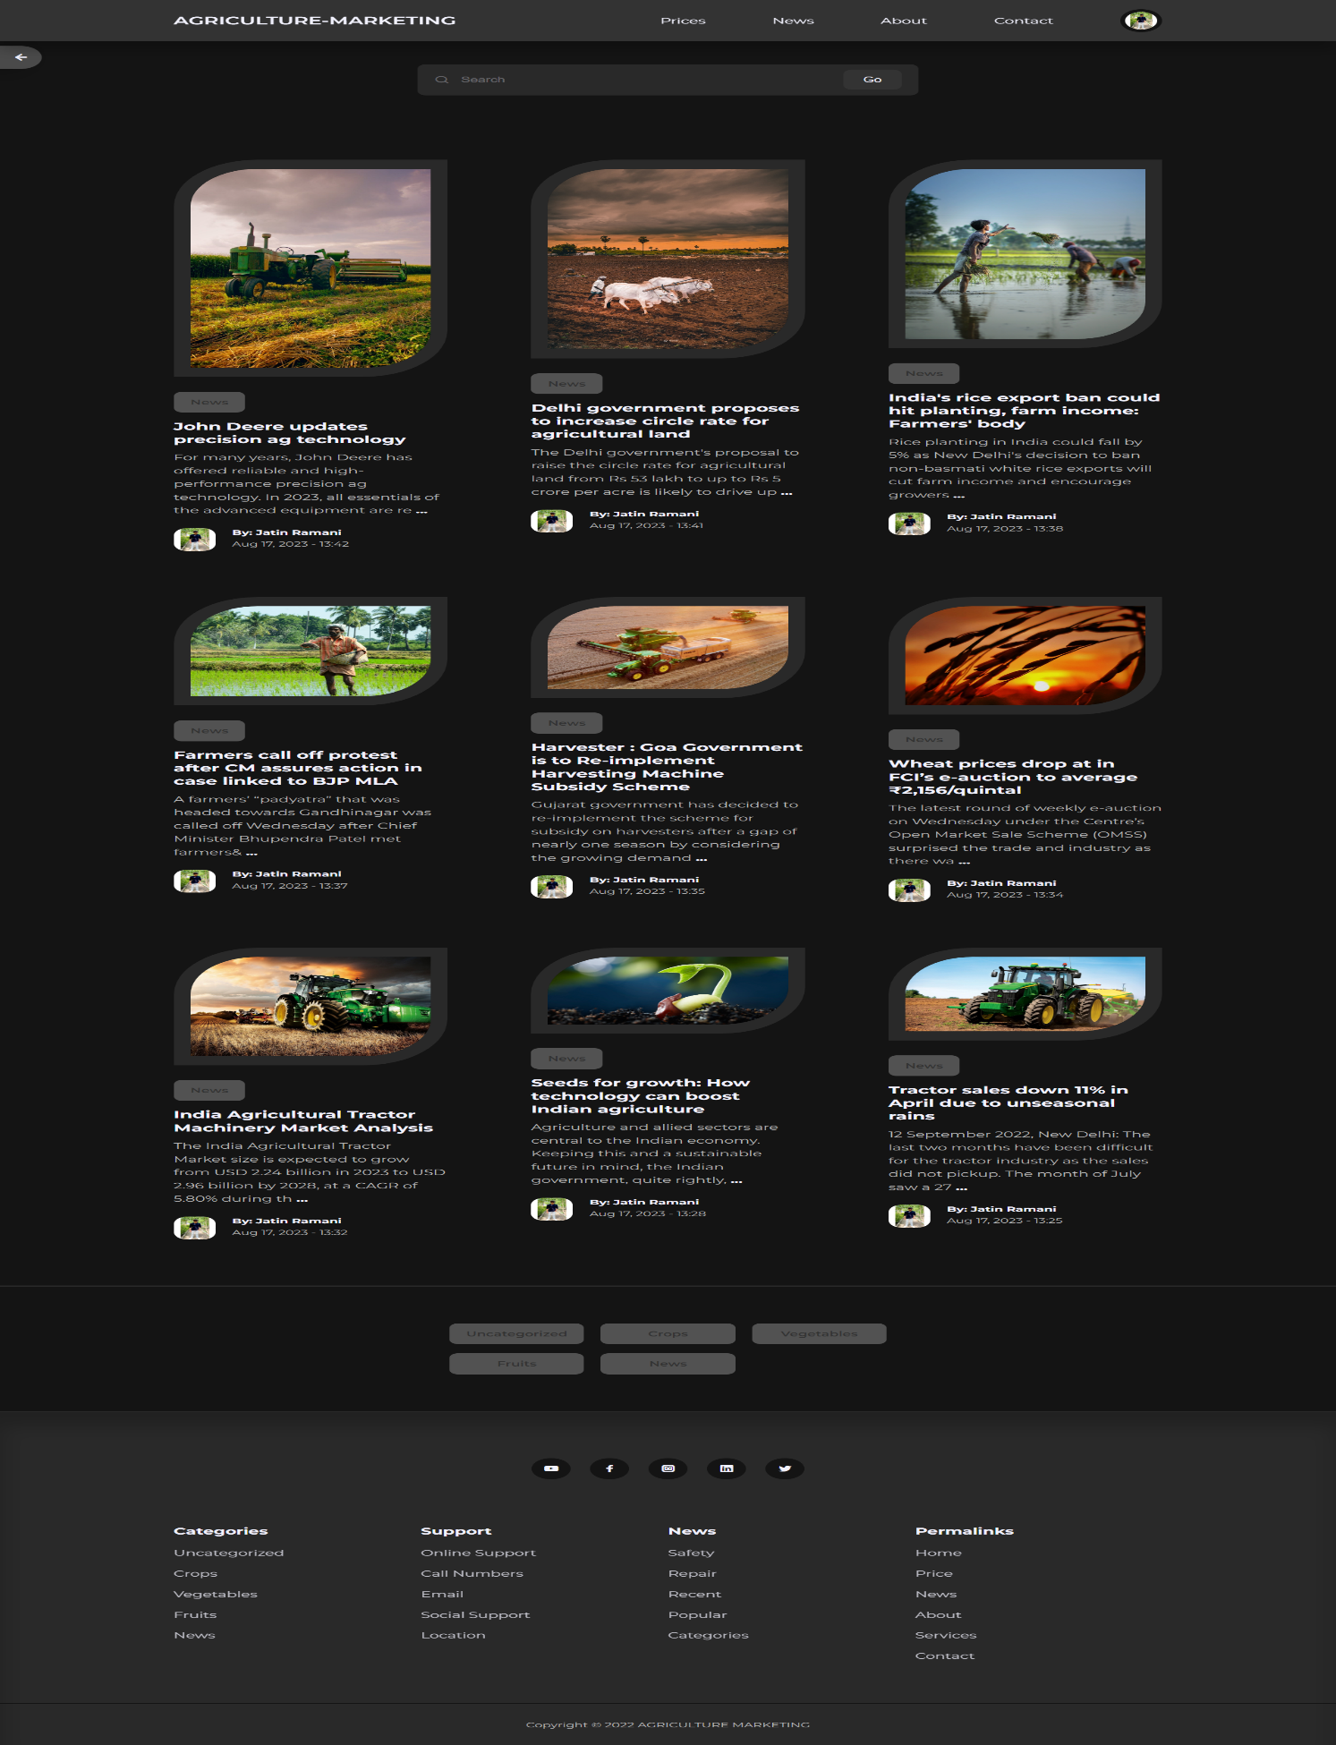the News Page where user can view all the Posts(News).

1. **Search District**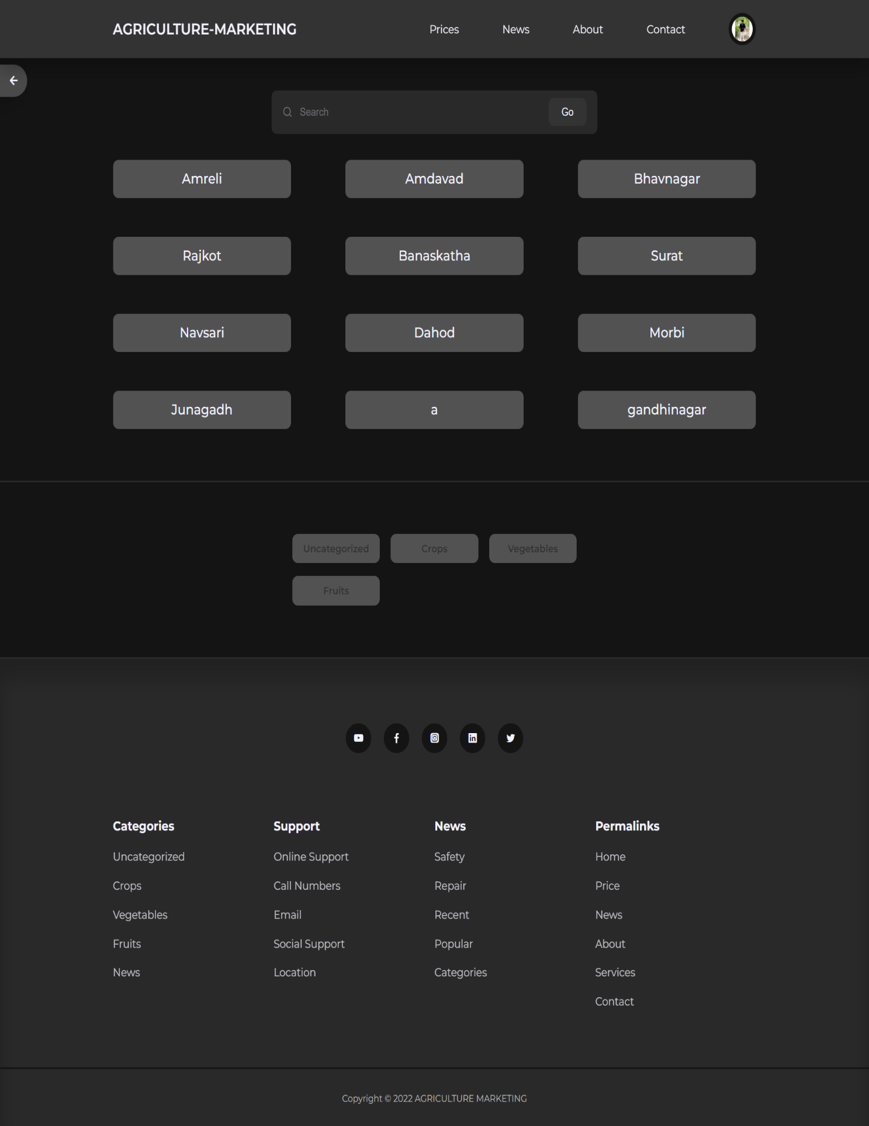

**Description :**

* Above screenshot is Price page where user can Search/View all Sellers/District Yard names.

1. **Show MarketPrice Table**

**Description :**

* Above screenshot is perticuler seller’s Price List Table where user can see all Product prices and compare.

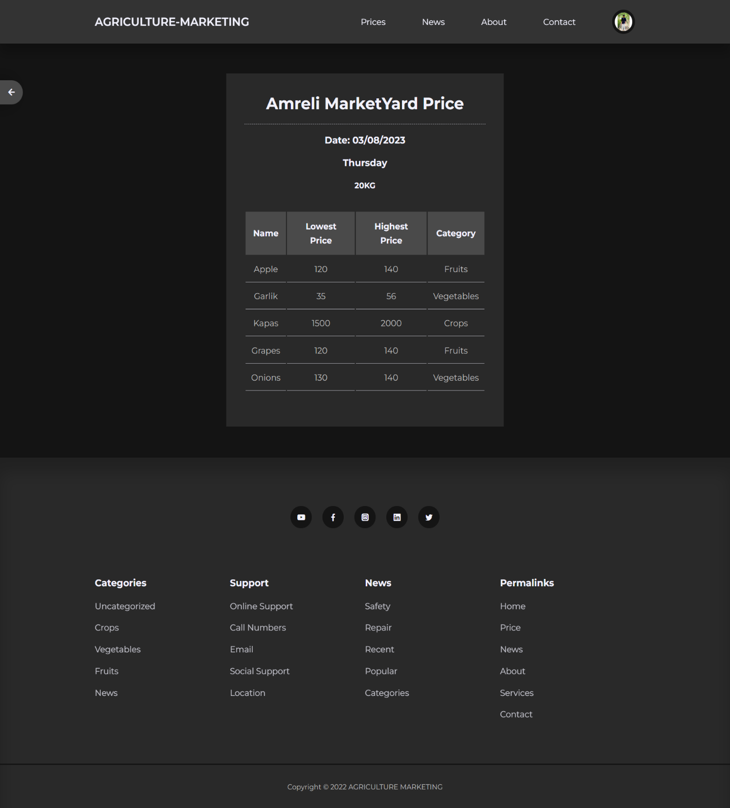

1. 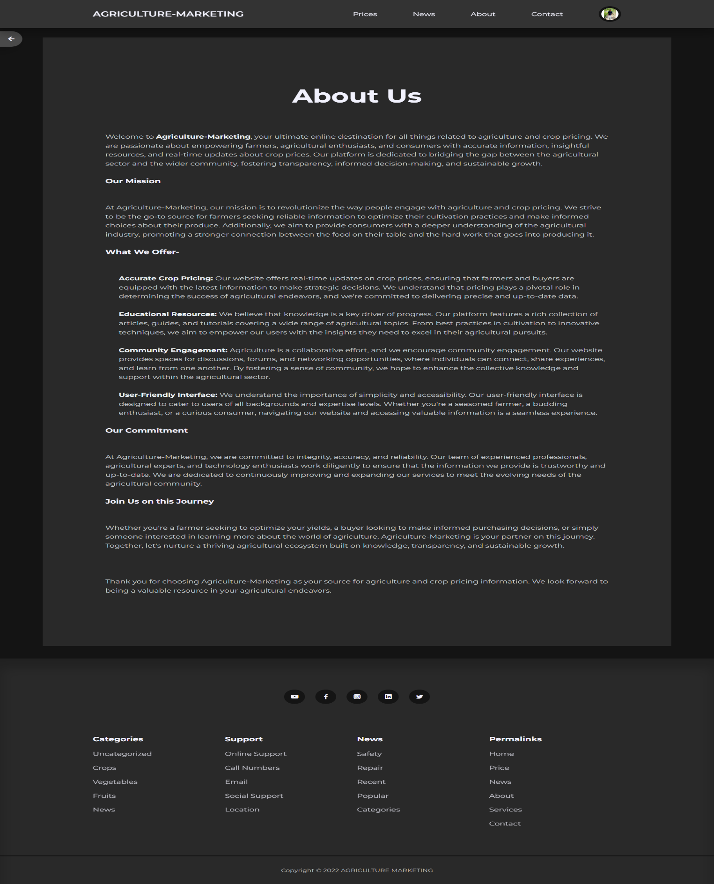**About Us**

**Description :**

* Above screenshot is About Us page.

1. 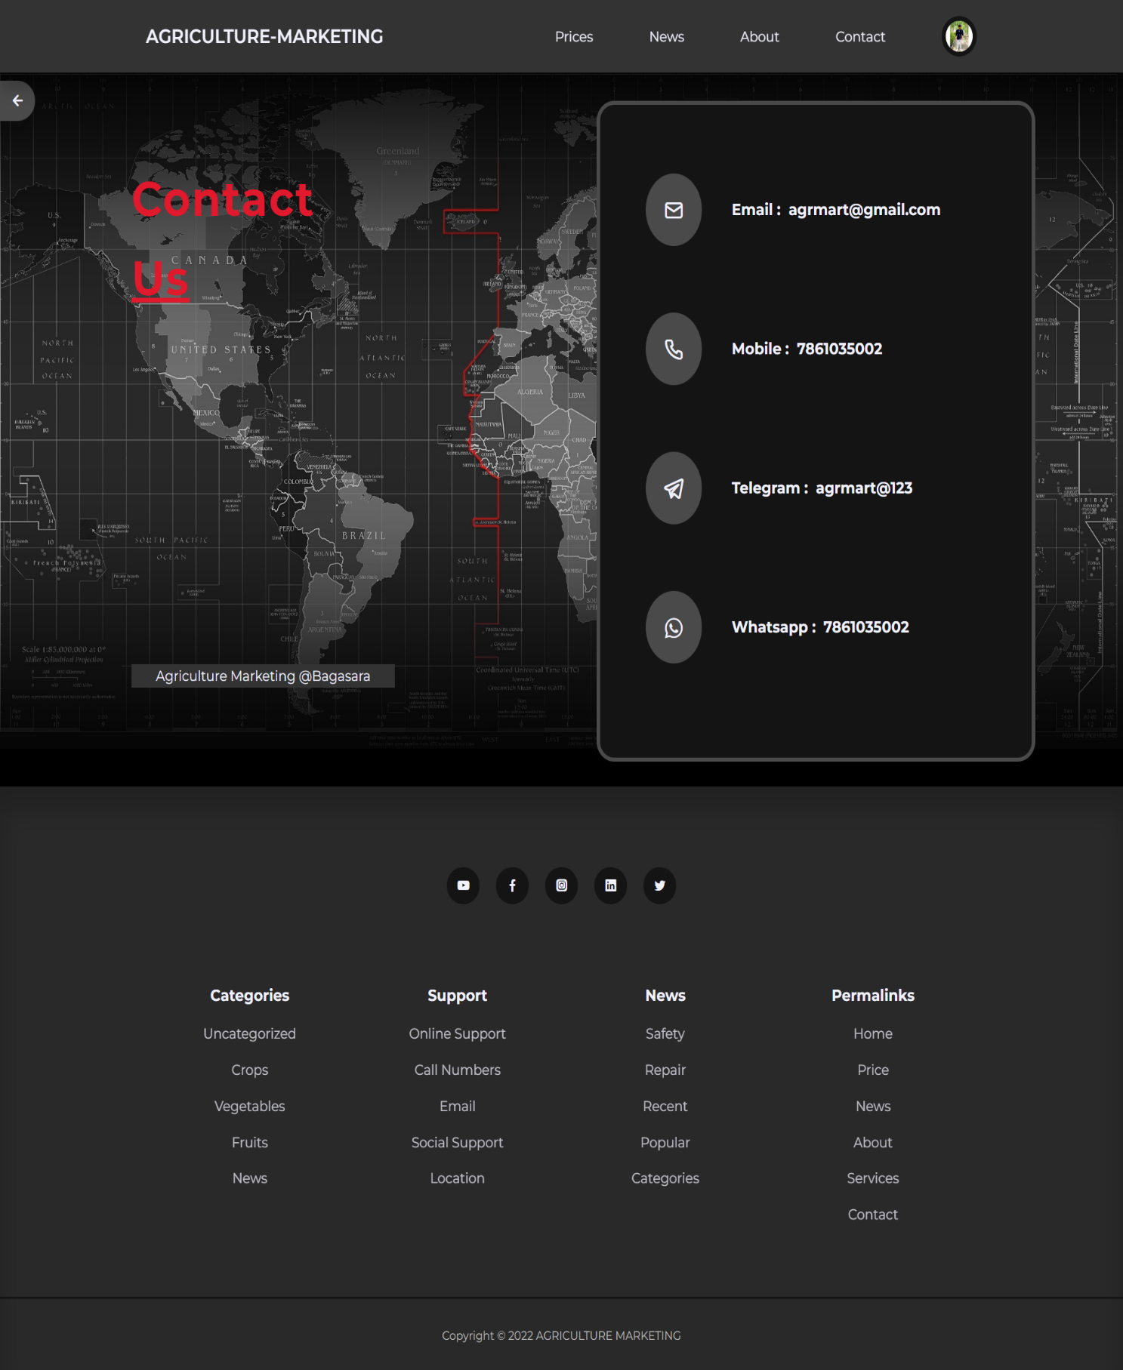**Contact Us**

**Description :**

* Above screenshot is Contact Us page.

1. **Sign in page**

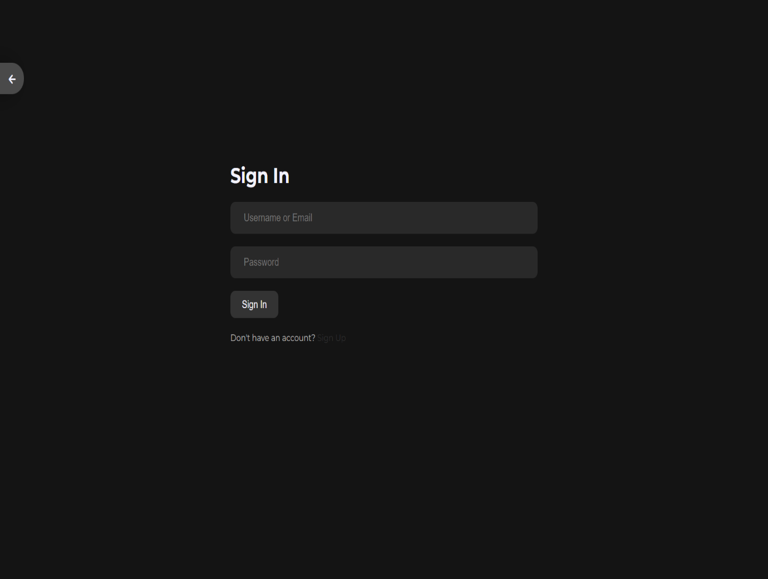

**Description :**

* Above screenshot is sign in page .
* Admin or sellers will access the admin pages after sign-in successful.

1. **Admin page**

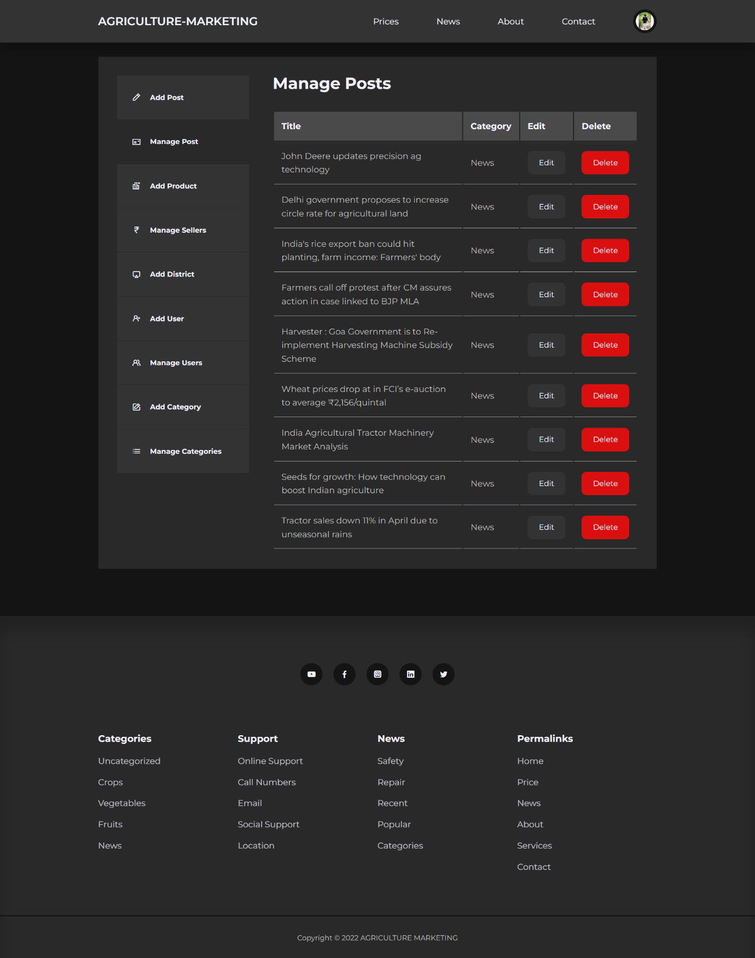

**Description :**

* Above screenshot is Admin side HomePage.
* Here admin can MANAGE/ADD/EDIT/DELETE anything .

1. **Admin add post**

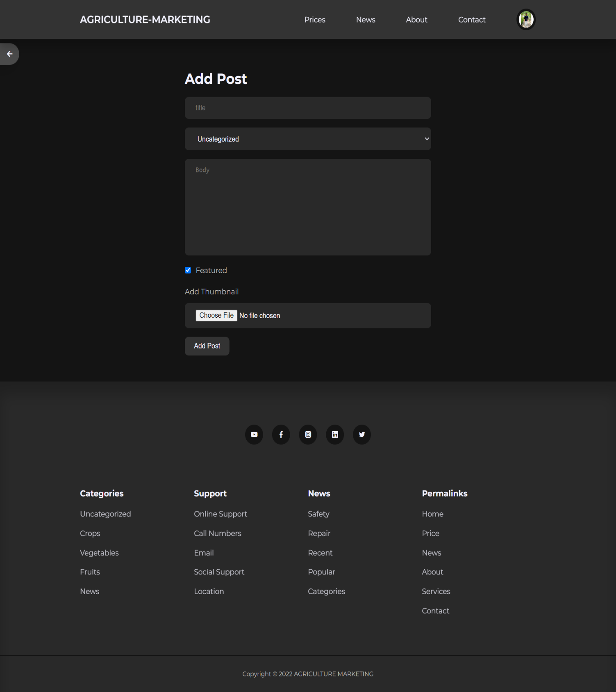

**Description :**

* This is Add Post page.
* Here admin can ADD new Post(News).

1. **Admin manage post**

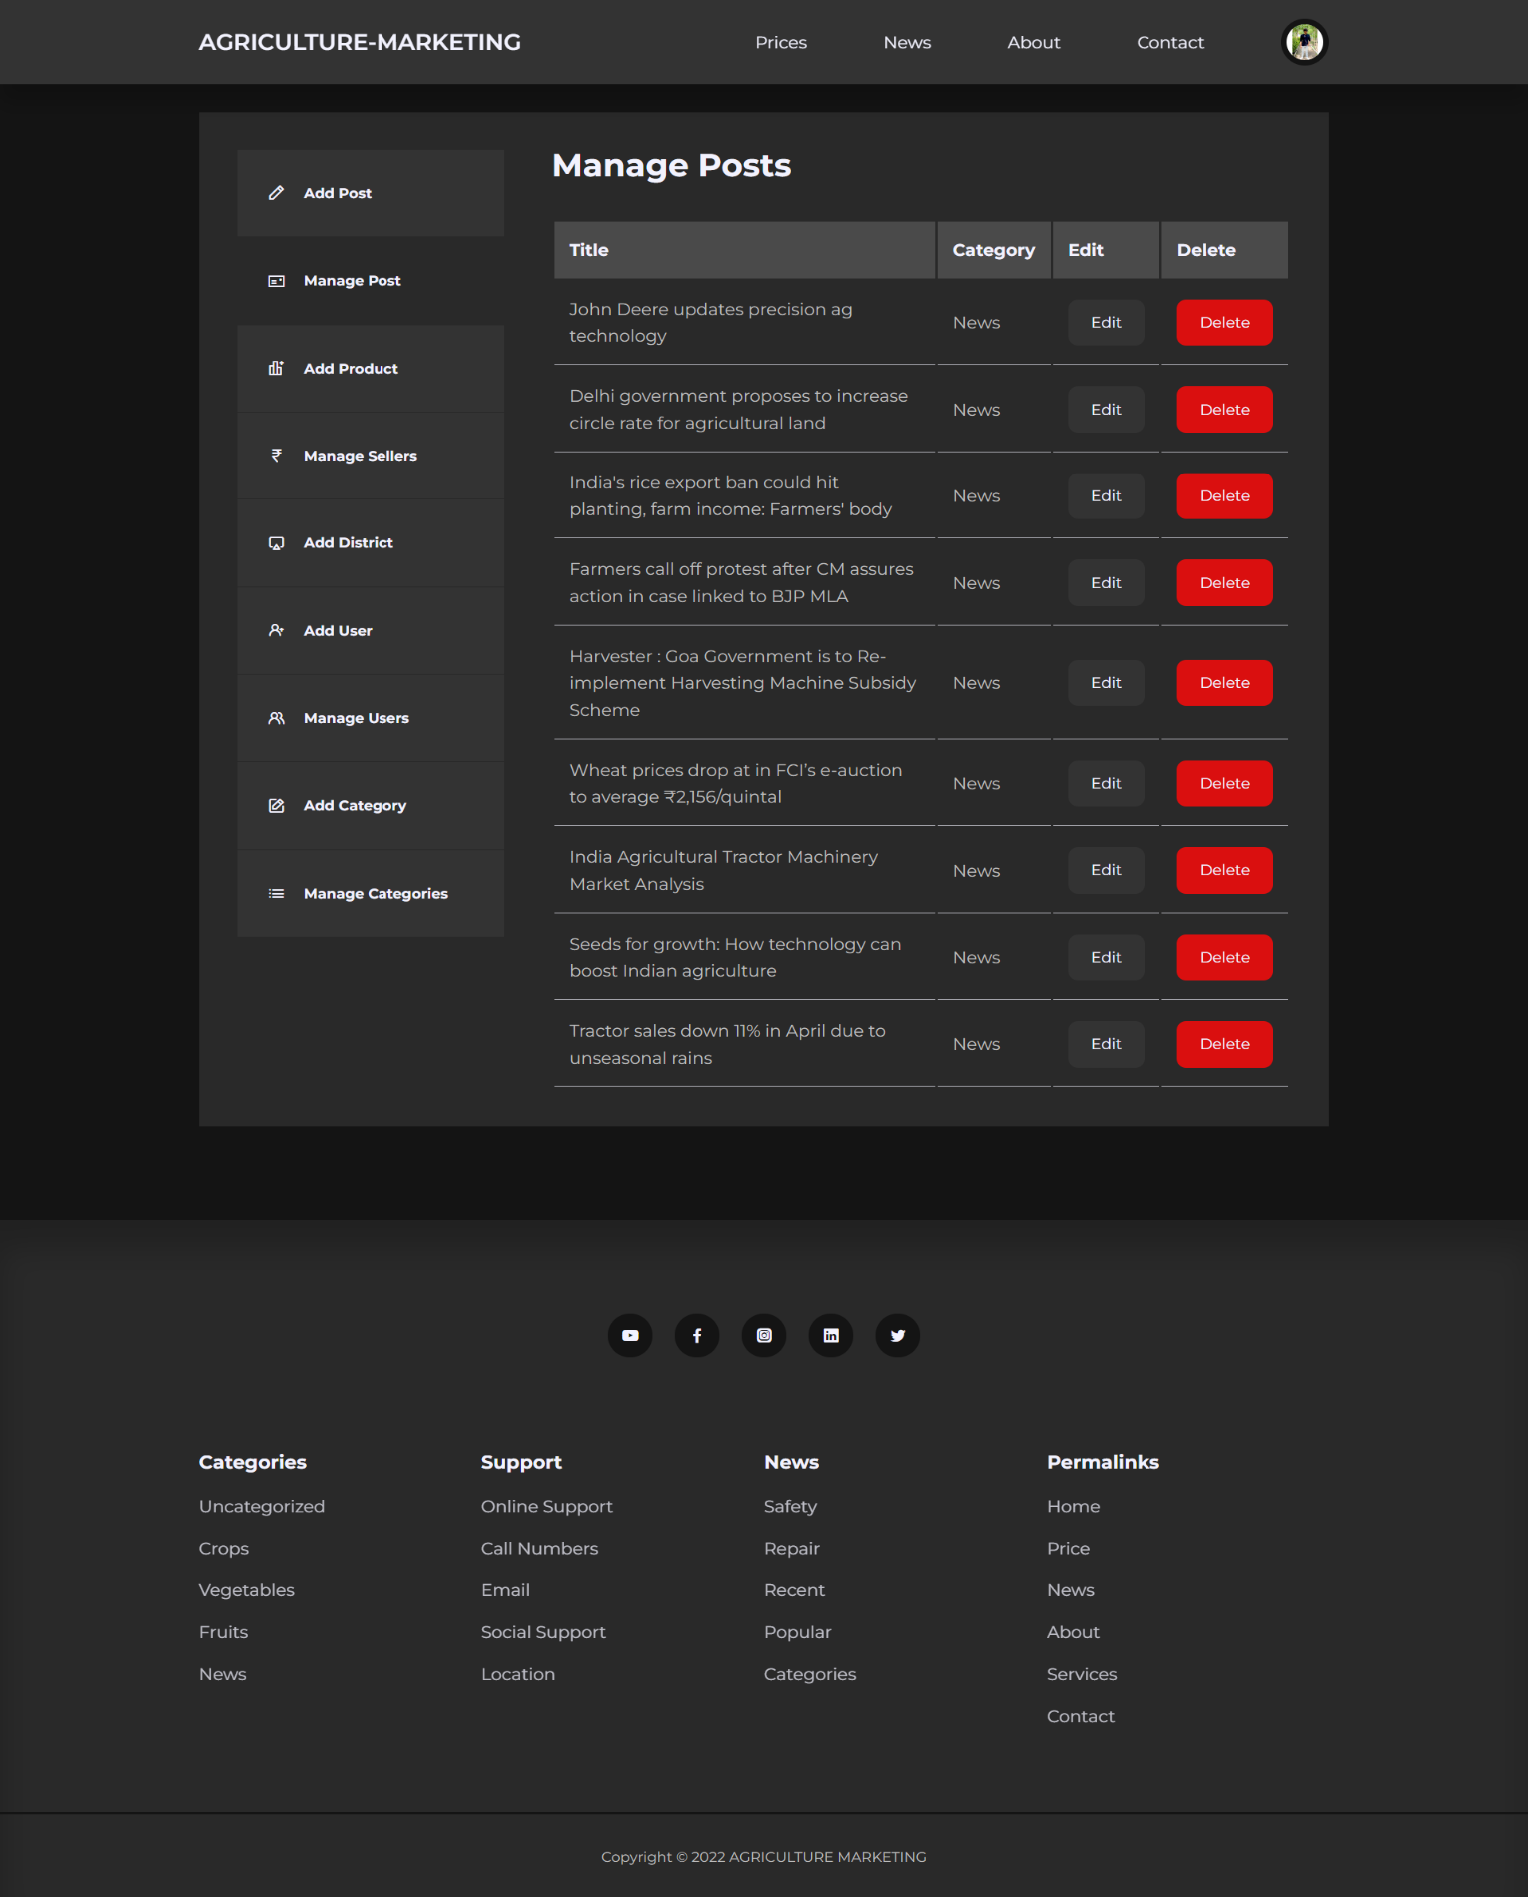

**Description :**

* This is Manage Posts Page.
* Here admin can VIEW/EDIT/DELETE the Posts(News).

1. **Admin add product**

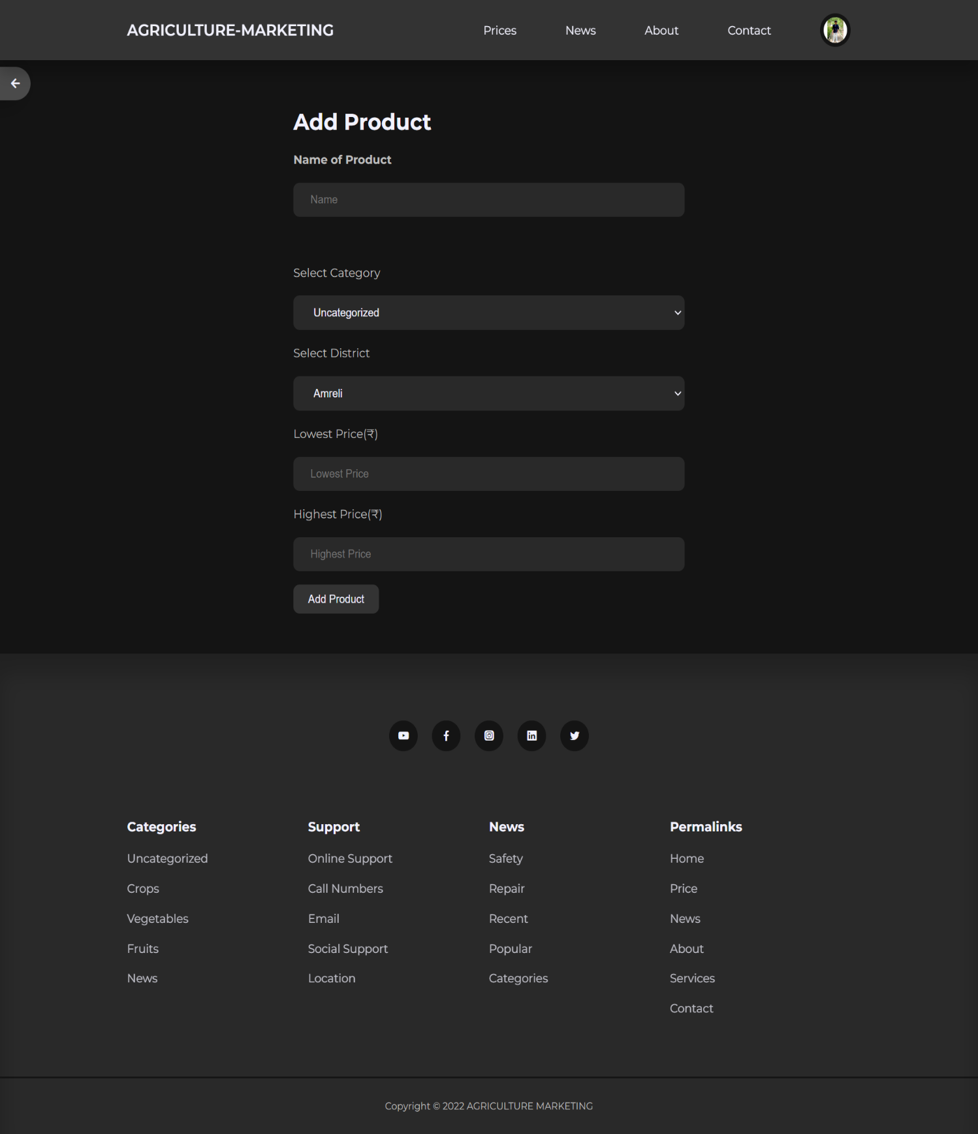

**Description :**

* This is Add Product page.
* Here admin can ADD new Product.

1. **Manage sellers**

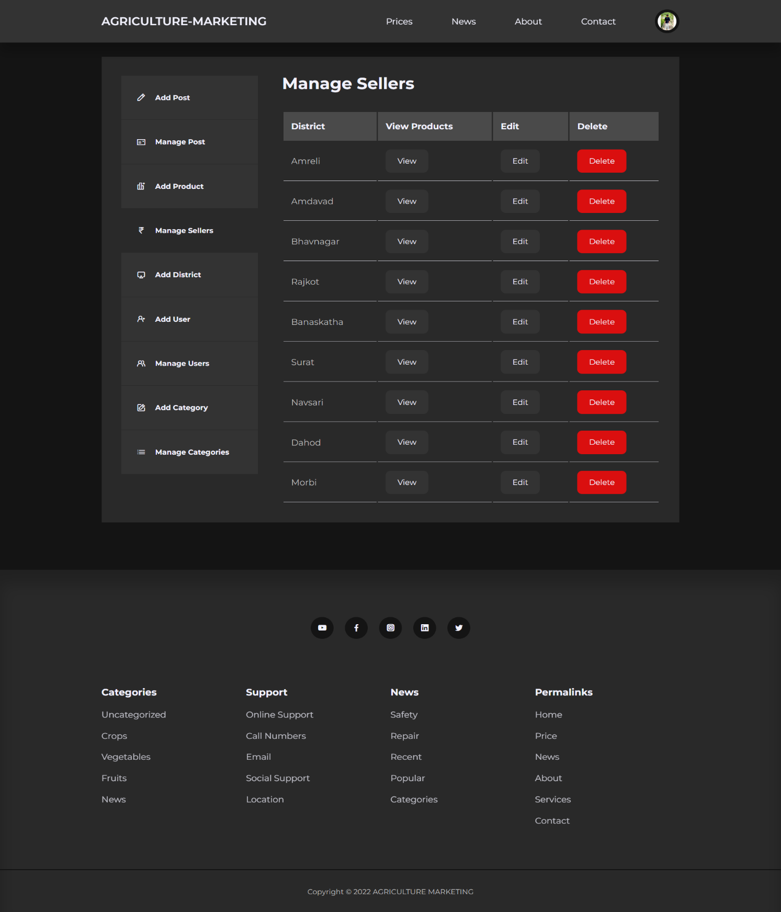

**Description :**

* This is Manage Sellers page.
* Here admin can VIEW/EDIT/DELETE the Districts and Products.

1. **Admin add district**

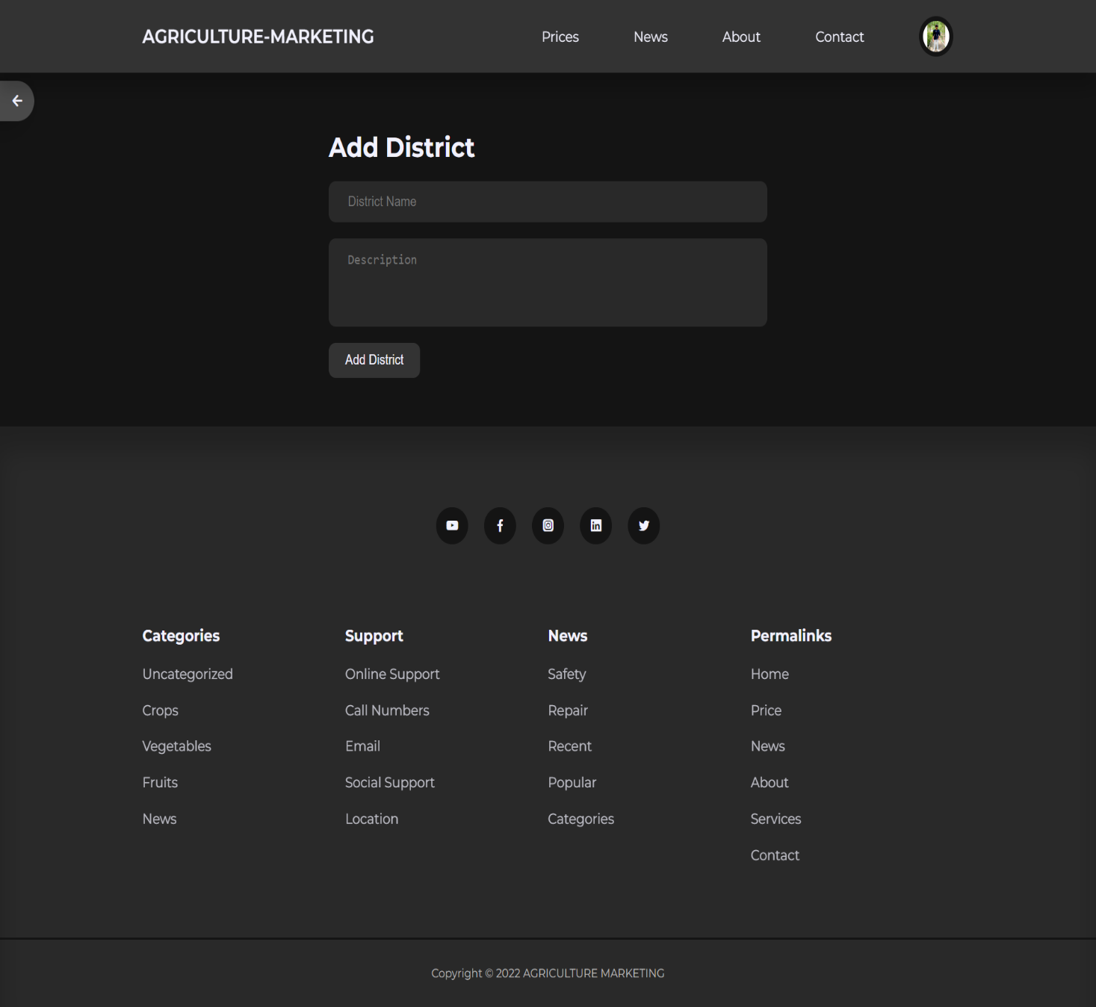

**Description :**

* This is Add District page.
* Here admin can ADD new District’s yard Name.

1. **Add user**

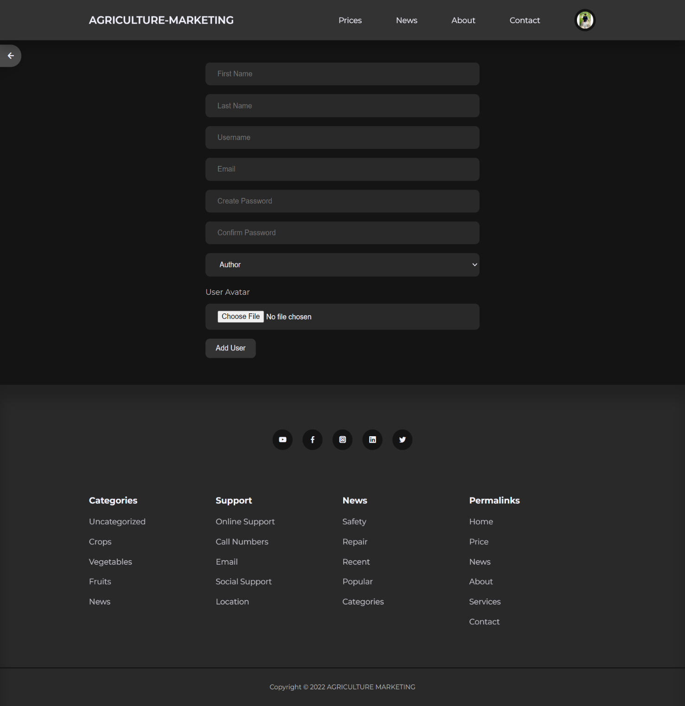

**Description :**

* This is Add User page.
* Here admin can ADD new User/Admin.

1. **Manage user**

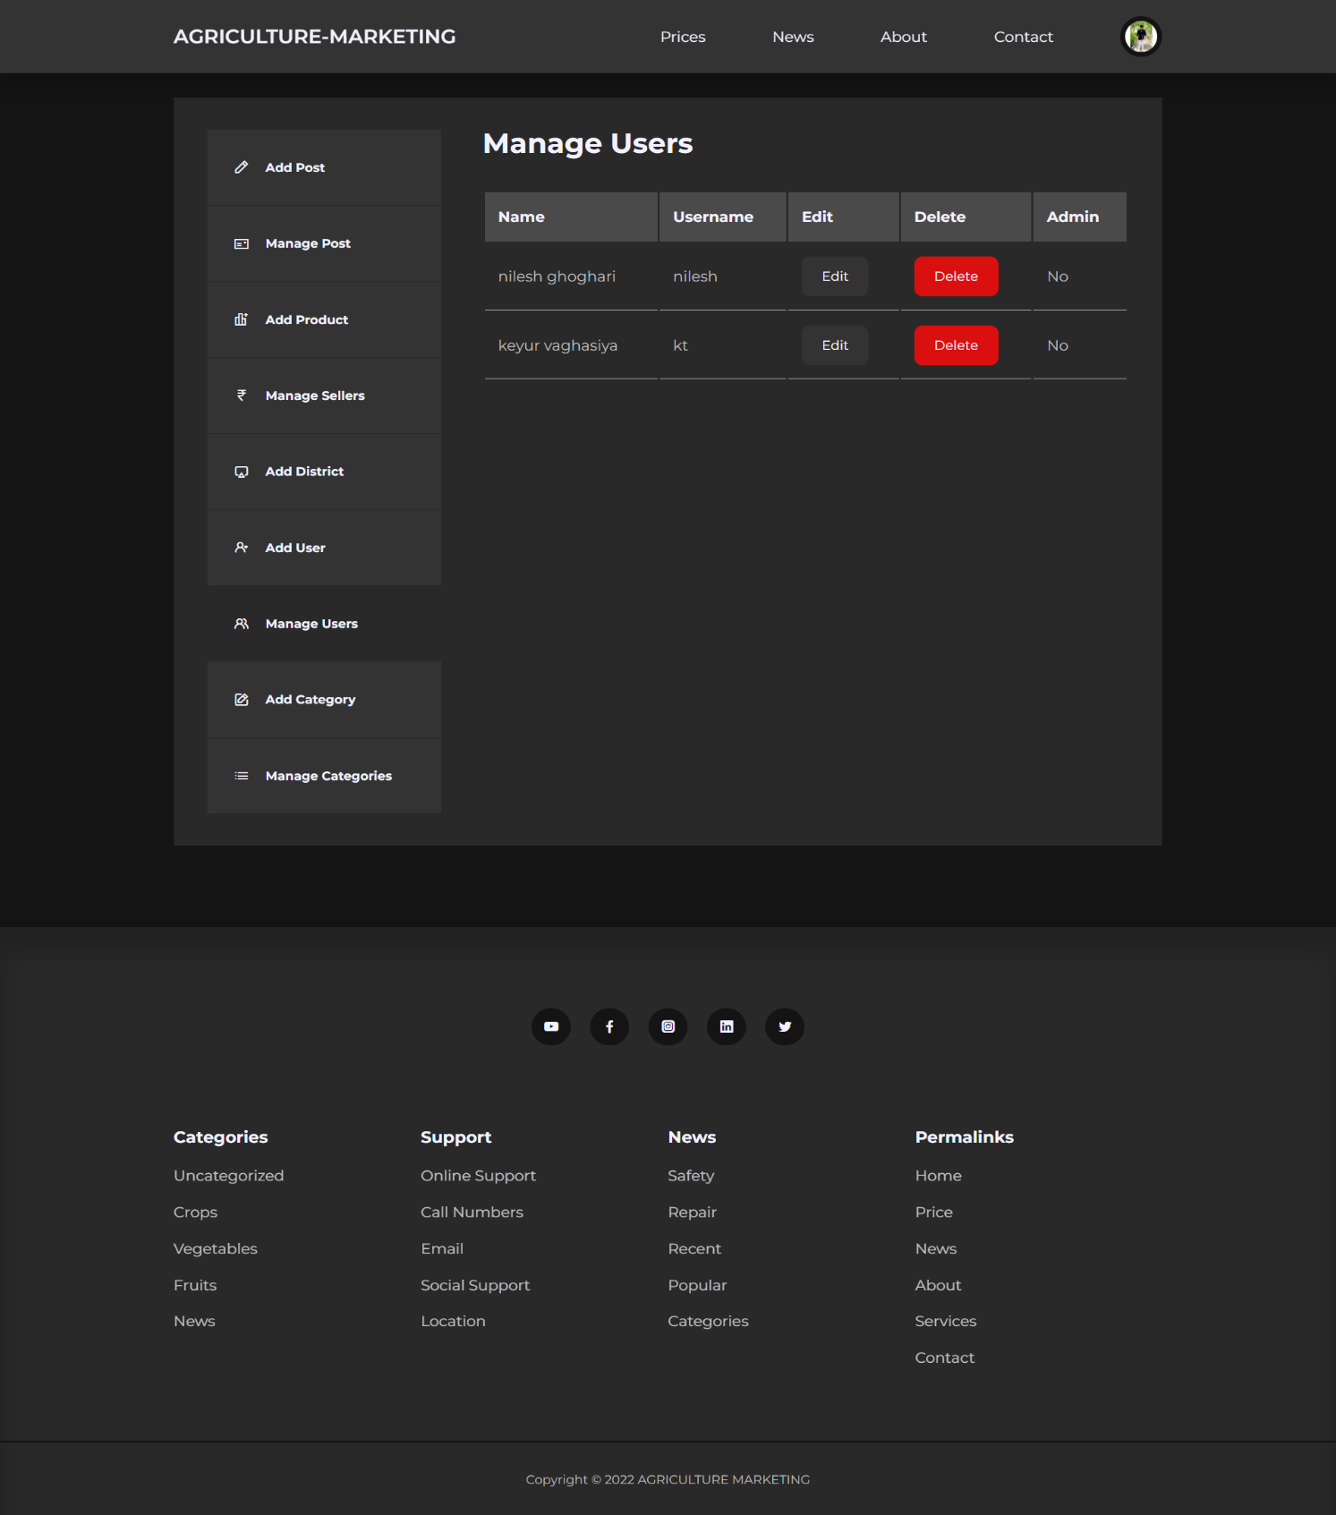

**Description :**

* This is Manage User page.
* Here admin can VIEW/EDIT/DELETE the Users/admin.

1. **Add category**

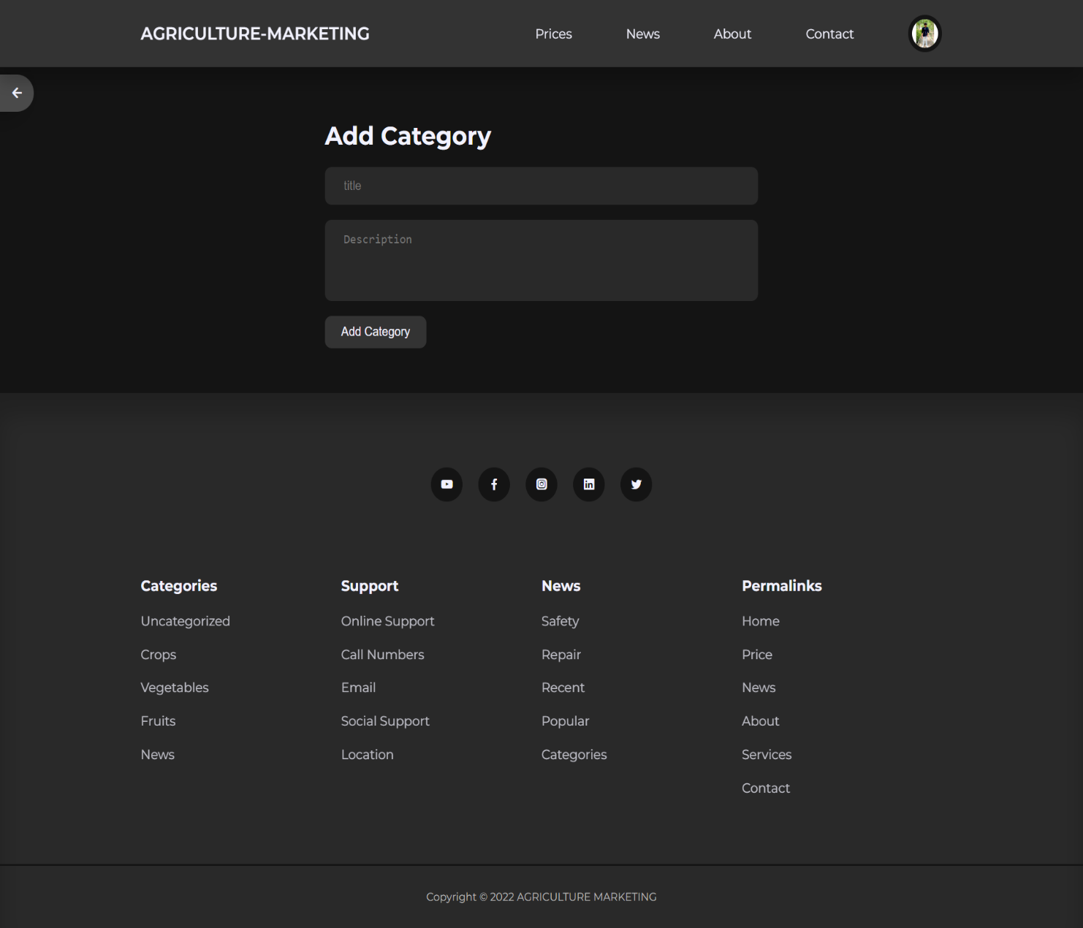

**Description :**

* This is Add Category page.
* Here admin can ADD new Category.

1. **Manage category**

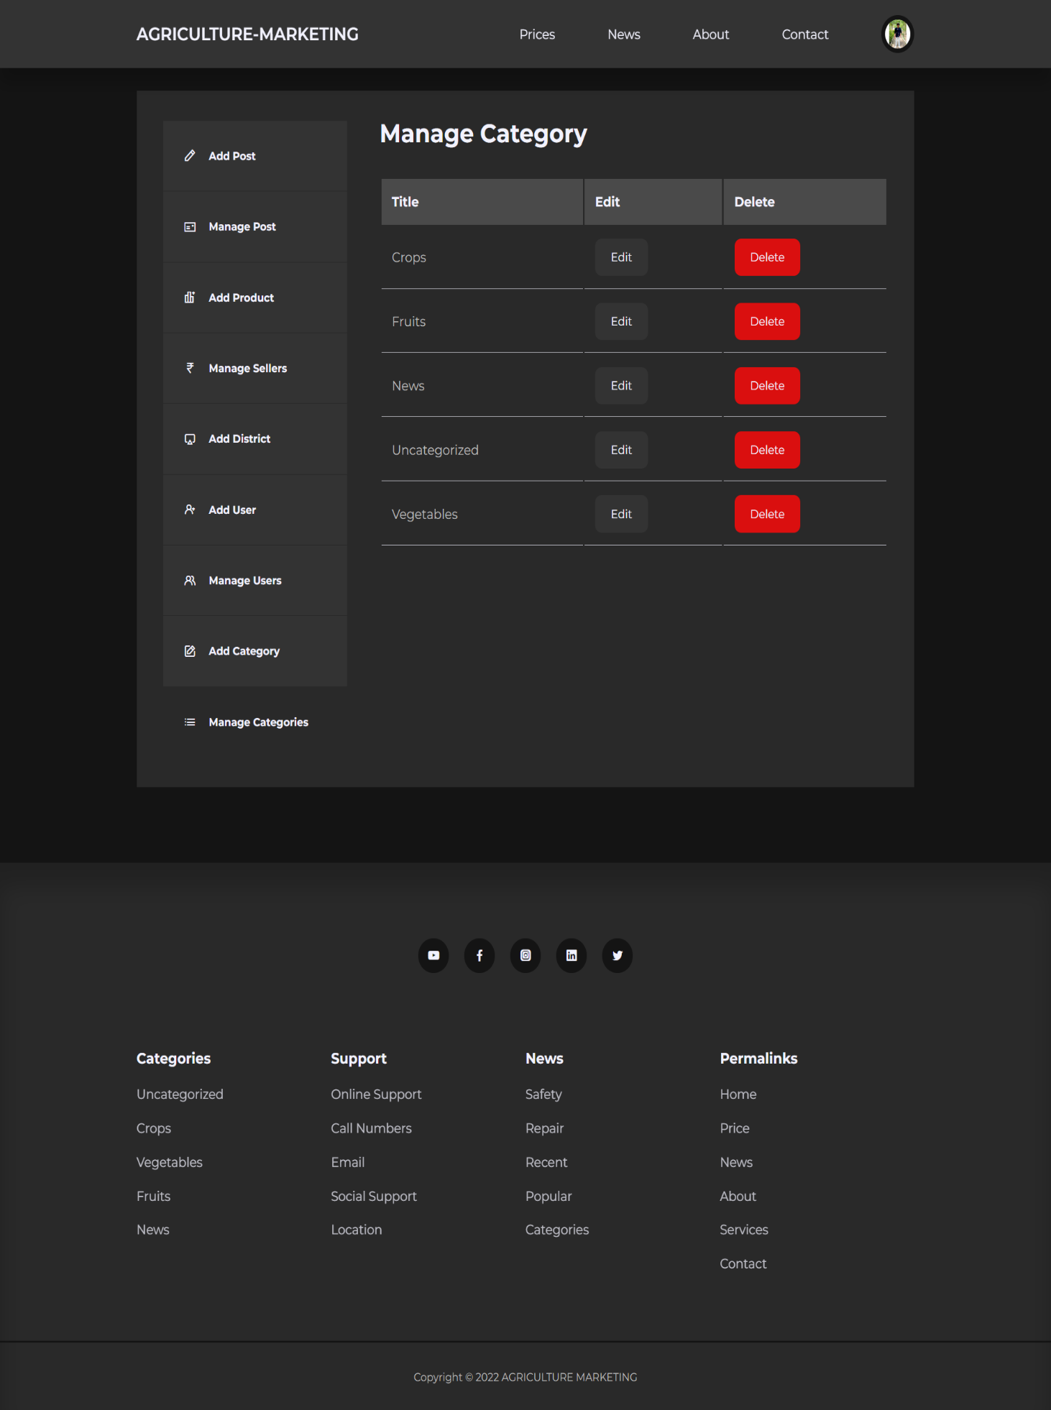

**Description :**

* This is Manage Categories page.
* Here admin can VIEW/EDIT/DELETE the Categories.

**9. System Testing**

1. **Unit testing**

* unit testing is the process of checking small prices of code to ensure that the individual parts of a program work properly on their own.
* Unit tests are used to test individual blocks (units) of functionality. unit testing is done by developers.

1. **Integration testing**

* Integration testing is conducted to evaluate the compliance of a system or component with specified functional requirements it occurs after testing and before system testing
* Types of integration testing

1. **Big – bang**
2. **Mixed (sandwich)**
3. **Top – down**
4. **Bottom – up**
5. **System testing**

* System Testing is a level of testing that validates the complete and fully integrated software product.
* The purpose of a system test is to evaluate the end-to-end system specifications.
* System Testing is a black-box testing.
* System testing categories based on functional / non – functional requirement.

**Test cases**

**Test case – 1**

**Input:** user registration

**Output:** user registration successfully

**Test case – 2**

**Input:** user login

**Expected output:** if user want to login for that user must create registration if user previously not create account

**Actual output:** user login successfully

**Pass:** yes

**Test case – 3**

**Input:** user enter invalid username or password

**Expected output:** it displays error message

**Actual output:** invalid username or password

**Pass:** yes

**Test case: 4**

**Input:**  enter all information of require field

**Expected output:** user has successful create login and also registration if all details and invalid user enter personal information user detail will be verify in database

**Actual output:** user has successfully registered

**Test case: 5**

**Input:** search product

**Expected output:** user can search for event his desire and requirement

**Actual output:** user can show all event his search

**Test case: 6**

**Input:** add product

**Expected output:** when admin to insert new product it can be added to the database with require information.

**Actual output**: product add successfully

**Pass:** yes

**10. Implementation Planning**

* Implementation of the new system is very critical and very complex Implementation has any many activities that are necessary from the old system to the new system. Proper implementation and installation are very useful.
* Proper installation will do user of this system will get the original advantages of the system then only.
* The implementation is very useful from the side of development. In some situations, a physical representation is developed and treated as the first step in software design. But most computerized system is specified in such a manner that it dictates accommodation of implementation’s list and its details.
* The implementation of the software development life cycle can also complete at the end-of-life cycle process.
* These are the advantages of the implementation before installing the product or the software. Without the proper implementation of the system the customer or the user Can’t work properly and as they expected in the SRS document.
* **Waterfall Model**

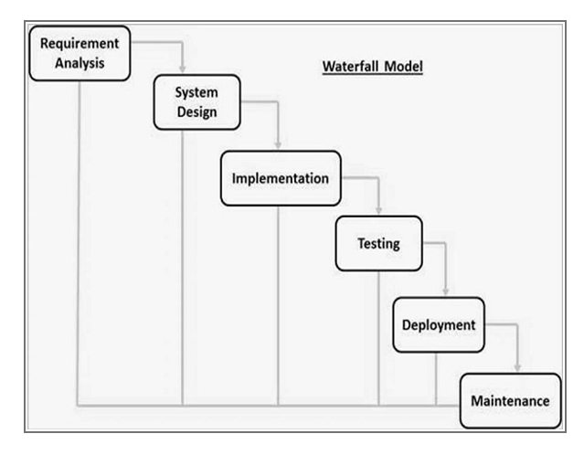

**Module**

* **User side**
* User registration
* User login
* User add post
* User manage post
* Add product
* Manage sellers
* Add district
* User view price, news, about, and contact pages.
* User show price
* User view the news blogs
* User contact
* User logout
* **Admin side**
* Admin login
* Add post
* Manage post
* Add product
* Manage sellers
* Ad district
* Add user
* Manage user
* Add category
* Manage category
* Admin show price, news, about and contact pages
* Admin show prices
* Admin show news and blogs
* Admin logout

**11. Bibliography**

**For PHP**

**•** [**https://www.w3schools.com/php/default.as**](https://www.w3schools.com/php/default.as)

**•** [**https://www.sitepoint.com/php/**](https://www.sitepoint.com/php/)

**•** [**https://www.php.net/**](https://www.php.net/)

**For MySQL**

**•** [**https://www.mysql.com/**](https://www.mysql.com/)

**•** [**http://www.mysqltutorial.org**](http://www.mysqltutorial.org)

**For XAMPP**

**•** [**https://www.apachefriends.org/download.html**](https://www.apachefriends.org/download.html)

**Books:**

* **Website development using php-Bharat prakashan.**
* **Network & internet environment-Bharat prakashan.**
* **Analysis & internet environment -Jams A. sem.**